Major Comments
- Overstatement of Behavioral “Optimization”
The manuscript frequently implies fish are optimizing habitat use based on physiological criteria (e.g., minimizing energetic cost, maximizing aerobic scope). However, without direct metabolic measurements, these claims are unsupported. Reframe to emphasize behavioral patterns consistent with predicted trade-offs rather than physiological optimization.
    - Thank you for this suggestion. We have revised the manuscript to remove language implying optimization and now frame the observed behaviors as consistent with balancing trade-offs between temperature and dissolved oxygen (e.g. lines 2-3, 25-26, 38-39, 82).
- Collinearity of Temperature and DO
DO and temperature are strongly correlated (r ≥ 0.8), yet the resource selection model interprets marginal effects of temperature while holding DO constant at 4 mg/L. This simplification is biologically unrealistic and could mislead readers. Suggested alternatives include:
  - Generalized Additive Models (GAMs) with interaction terms
  - Principal Component Analysis (PCA) to reduce the trade-off to a single axis
  - If marginal plots are retained, a clear caveat is needed to acknowledge their conceptual (not empirical) nature
    - We considered the reviewers’ suggestions of using GAMs with interactions or PCA. PCA doesn’t appear suitable given the small number of covariates. We explored using GAMs in our initial review of the data and opted against them because the fitted surfaces can extrapolate beyond the range of actual conditions available at a single time step - since temperature and DO both vary over time, making interpretations outside of their observed combinations would not be appropriate. Instead we opted to create simple plots of the raw used and available temperature and DO during the windows of DO-maxima and DO-minima.
- DO Constraints Challenge Core Interpretation
According to Figure 1 and known physiological thresholds, DO is below 4 mg/L throughout the water column during the morning. This undermines the claim that DVM during that period reflects a depth-based trade-off between DO and temperature, as there’s no spatial variation in DO to exploit. This challenges the central conclusion and requires either reinterpretation or stronger justification.
    - Thank you for raising this important point. We agree that in the early morning hours, absolute DO levels were low across the water column, and we have clarified this in the manuscript. However, even during these periods, small but biologically relevant vertical gradients in DO persisted (often ~1–1.5 mg/L across depths; see Figure 1c and 1d). While these differences may appear minor, they are consistent with the vertical distribution of fish, suggesting that even modest variation in DO can influence behavior under stressful conditions.
We have added text to the Results (line 336) and Discussion (line 396) sections to clarify that during DO minima, the observed DVM likely reflects fish avoiding the most hypoxic zones while simultaneously minimizing exposure to surface temperatures that exceed thermal optima. We now interpret DVM during this period as a behavioral response to a constrained environment, where movement reflects an attempt to balance multiple suboptimal conditions.
- Simulation Outputs Lack Biological Realism
The “DOmax” and “Tmin” behavioral strategies shown in Fig. 4a are unrealistic flat lines with no temporal variability, confidence intervals, or behavioral nuance. These simulations undermine biological credibility and suggest model parameters or assumptions need refinement. Consider adding confidence intervals or uncertainty to reflect more realistic behavioral variation.
    - We appreciate this suggestion and have clarified in the Methods (lines 170–173) that these strategies are based on simple rank-based simulations designed to illustrate expected behavior under fixed temperature- or DO-based selection. Because the simulations are conceptual and not fit to empirical data, adding confidence intervals would be arbitrary. Their purpose is to provide a simplified contrast with the more variable depth use observed in tagged fish.
- Confinement Effects Not Addressed
The potential behavioral constraints of net pens are not discussed. These may alter fish movement, limit natural responses, exclude predators/prey, or affect energetic demands. Authors should clarify the size of pens relative to typical fish movement and acknowledge limitations.
    - We have added text in the Discussion to acknowledge the potential constraints imposed by the net pens (lines 439-446). Specifically, we note that fish had access to the full depth of the water column within a relatively large enclosure, and that fish in the wild often appear stationary and do not exhibit large lateral movements unless startled (Supporting Information Video S1). We also emphasize that observed patterns of vertical movement in the net pens were consistent with both simulation predictions and selection model outcomes, lending confidence to our behavioral interpretation. Nonetheless, we now explicitly recommend that future studies incorporate free-ranging telemetry to further evaluate behavioral plasticity in natural settings.
- Missing Physiological Thresholds
The study interprets behavior in terms of physiological trade-offs but omits relevant physiological parameters such as CTmax, Pcrit, thermal optima, or hypoxia thresholds for cutthroat trout. Including these would support the simulations and behavioral interpretations.
- Lack of Fish Size Information
No details are provided about the size of tagged fish, yet body size is known to influence thermal physiology. Size should be reported and considered as a covariate or scaling factor in physiological interpretations and models.
    - We have added the mean fork length of tagged fish (286.6 ± 58.3 mm; lines 341-342) to the Results section. While body size can influence thermal physiology, we did not include size as a covariate in our habitat selection models due to the relatively narrow size range.
- Statistical Results Not Well Integrated
Key results are relegated to the supplement and insufficiently discussed in the main text. Results should be more clearly referenced and interpreted, with emphasis on how they support or fail to support core conclusions.
- Pooling of Data in Figure 4c
Combining behavioral data from all individuals masks inter-individual variation and contradicts statements in the text (e.g., lines 425–426). Either disaggregate or explicitly justify this choice.
    - We thank the reviewer for this comment. While individual variation in vertical positioning was evident, our goal in Figure 4c was to highlight the central diel pattern in depth selection, which was broadly consistent across individuals. We have revised the Results text (lines 359-361) to explicitly justify our decision to present pooled data.
- Alternative Explanations for DVM
The interpretation focuses heavily on DO-temperature trade-offs, but other potential drivers of vertical movement—such as foraging behavior, light, predator avoidance, digestion, or reproductive cues—are underexplored. The Discussion should acknowledge these limitations and expand the interpretation accordingly.
    - Now addressed in paragraph (lines 456-468). Also adding used/available heat map plots to show responding to DO as well as temp.
- Questionable Journal Fit
The study’s specific system, taxon, and moderate scope of inference may make it more appropriate for a habitat- or species-specific journal unless broader ecological relevance can be more clearly established.
    - We appreciate the reviewer’s concern regarding journal fit and agree that our study focuses on a specific species and set of habitats. However, we believe the broader ecological relevance is supported by both the novelty of our approach and the generality of the mechanisms explored. While our focal species is coastal cutthroat trout, the trade-offs we highlight arise from first principles of metabolic ecology and oxygen limitation, which are broadly applicable across ectothermic aquatic taxa. Temperature–oxygen trade-offs are increasingly common in freshwater systems globally due to climate-driven warming. By demonstrating how diel variation in these stressors can drive emergent behavioral patterns such as DVM, our work advances understanding of how fine-scale temporal dynamics influence habitat selection. We have revised the Discussion to more explicitly highlight this broader relevance (lines 497-499, 512-514).

Minor Comments
- Terminology Clarification
  - Define "lotic" and "lentic" for a broad readership.
    - We have added definitions for “lotic” and “lentic” at first mention to increase accessibility for general audience (line 51-52).
  - Replace or clarify “day” and “night” in DO timing (e.g., 6–8 a.m. = “night”) with “DOmax” and “DOmin” to prevent confusion with photoperiod-based behaviors.
    - We replaced references to “day” and “night” in the Results with “DO-maxima” and “DO-minima” to clarify that these refer to dissolved oxygen timing windows, not photoperiod (e.g., Lines 241-242, 384-385).
- Literature Gaps
  - The Introduction lacks sufficient citation of relevant studies, particularly those documenting diel variation in temperature and DO in marine systems.
    - We have revised both the Introduction and Discussion to incorporate additional citations that document diel and vertical variation in temperature and dissolved oxygen in marine systems. Specifically, we added references to Brill et al. (1999), Bianchi et al. (2013), Logan et al. (2023), and Prince & Goodyear (2006) to highlight how oxygen and temperature gradients shape vertical habitat use in marine fish.
  - Adjust claims of novelty to focus on shallow freshwater systems and acknowledge existing marine studies.
    - We thank the reviewer for this important suggestion. We revised the end of the Discussion to clarify that DVM is a well-documented phenomenon in marine systems, especially in relation to light, oxygen, and predation risk (e.g., Zaret & Suffern, 1976; Brill et al. 1999; Bianchi et al. 2013; Logan et al. 2023). We now more clearly frame our study as contributing to a knowledge gap in freshwater systems, where much less is known about the role of DVM in mediating physiological trade-offs between temperature and DO.
- Figure and Table Improvements
  - Add Y-axis label to Figure 2.
    - Y-axis label added to Figure 2.
  - Fix closing parenthesis in Figure 4b caption.
    - Removed closing parenthesis from caption
  - Add raw data points to Figure 3 to allow readers to assess model fit.
    - We agree that showing raw data can be helpful, but we chose not to include them in Figure 3 because the plotted lines show modeled trends based on fixed effects. The raw data are dense and overlapping due to repeated measurements across sites and time, which made the figure difficult to interpret when included (see example below). To maintain clarity and focus on the overall temperature–DO relationship during the high and low DO windows, we presented only the model fits in this figure.
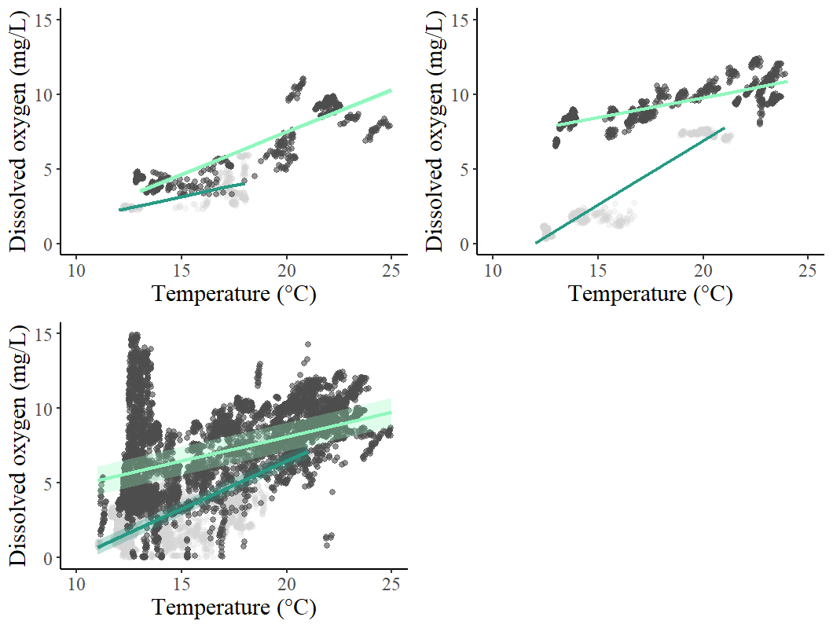
  - Provide complete and descriptive headers for Tables S2 and S3.
    - Headers modified for both Tables S2 and S3 to make more descriptive
- Clarify Methods
  - Move the 5-day recovery period detail earlier in the Methods to provide necessary context for interpreting behavioral data.
    - 5-day recovery detail moved earlier in methods (line 248).
  - Explain how and whether “Year” was tested and discarded as a random effect in modeling.
    - Added explanation that year was tested and discarded because it did not improve model fit (line 244-45).
- Rephrase Ambiguous Statements
  - Line 432 (“they barely feed”) is unclear—specify whether it refers to reduced intake or unmet energy needs due to environmental constraints.
    - We clarified this statement in the Discussion to specify that fish in these alcoves likely do not meet energetic demands due to limited feeding opportunities however their energy intake was likely comparable to fish not in captivity based on unpublished data (paper currently in review).
- Improve Referencing in Results
  - Reference figures and tables more consistently in the Results (e.g., lines 113–122) to guide the reader.
    - We reviewed the Results section and ensured that all figures and tables are referenced appropriately where relevant.
- Avoid Over-Generalization
  - Temper general claims in the Discussion (e.g., lines 386–388). Emphasize the conceptual insight (e.g., asynchronous stressors may shape behavior in stratified habitats) rather than extrapolating broadly across species or systems.
    - We revised the relevant section to focus more clearly on the conceptual insight that asynchronous diel variation in temperature and oxygen may shape fish behavior in stratified habitats (Lines 391-392). We removed overgeneralized language and reframed the paragraph to emphasize that our findings may be relevant to other systems where similar stressor dynamics occur, rather than claiming broad generalizability.

